GREEN THUMB

Kristina Kovaleva

Michelle Trimpin

Juhi Sattar



Paul Davison

A WEB APP FOR LAWN SERVICE COMPANIES

Table of Contents

System Requirements 3

Installation 3

User Guide 4

Admin User 4

Customer User 14

# System Requirements

● Latest Installment of Java (Java 8.0)

● Windows (7, 8, or 10) OR Mac OS X

● Stable Internet connection

# Installation

There is no necessary download or installment needed for using the Green Thumb Lawn Services System (GTLSS). There will be a link provided to access GTLSS once it has been developed.



# User Guide

This guide is intended for users who have already followed the provided link to GTLSS. If you are reading this section but have not navigated to the web-application by clicking the link to GTLSS yet, please refer to the Installation instructions provided in this guide.

## Admin User

**Admin Login**

As an Admin User of the E-commerce web application, you will be able to access the Admin Portal that will allow administration of the business-related database. Through the Admin Portal, you will be able to manage your employees, equipment, lawn services and products.

* On the Home Page, you (the Admin user) should click on the "Admin Portal" button (highlighted in red on the diagram below), which will redirect you to the Admin Login page.

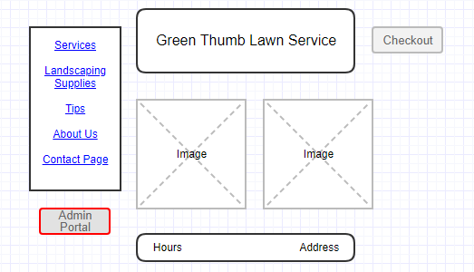

* On the Login page, you will have to provide the Admin username and password into the corresponding fields, and then click "Login" button (highlighted in red on the diagram below).

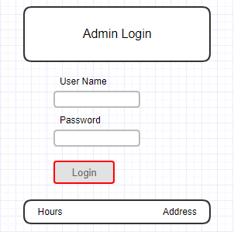

* On the Admin Portal page, you will be presented with a variety of administrative options that you may need to perform to manage your E-commerce business. This application comes with the following included administrative options:

1. Lawn Supplies
   * Add
   * Show
   * Update
   * Remove
2. Lawn Services

* Add
* Show
* Update
* Remove

1. Lawn Equipment

* Add
* Show
* Update
* Remove

1. Employees

* Add
* Show
* Update
* Remove

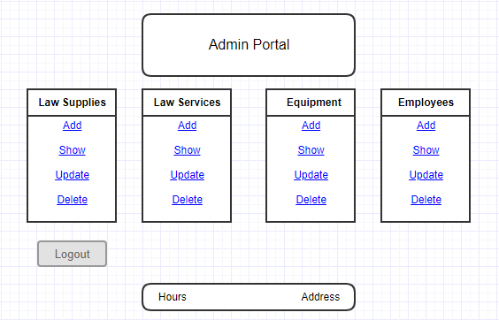

Note: This guide will provide instructions for adding, updating, and removing Supplies from the business-related database. The same instructions can be used to manage Services, Equipment, and Employees.

Warning: All modifications to the database data are final and cannot be reverted, so make sure you check all the selections and modifications before you finalize them by pressing the buttons Add, Update, or Delete.

**Adding Supplies**

When Add Supplies is selected (highlighted in red on the diagram below), the app will provide you with a form allowing you to add information about a new product (e.g. product name, path to the product image, product description, and product price). By entering the requested information and clicking Add button (highlighted in red on the diagram below), you will be able to add a new product in the business-related database.

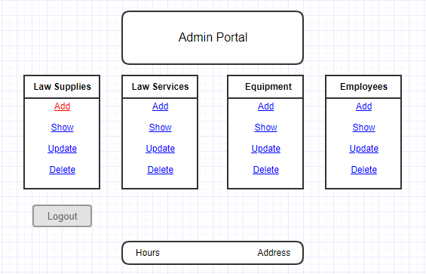

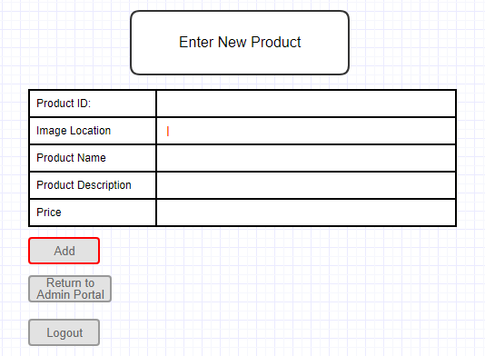

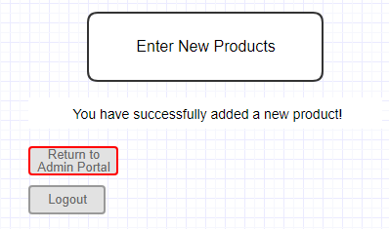

**Reviewing Supplies**

When Show Supplies is selected, the app will display all available supplies in the business-related database. This will allow you to review the product information and decide if anything needs to be updated in the Supplies database table.

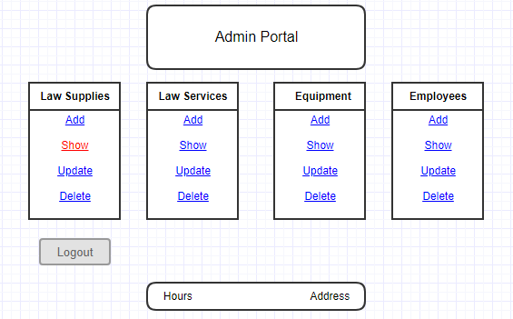

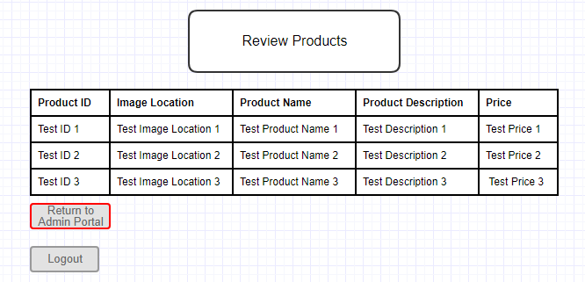

**Updating Supplies**

When Update Supplies is selected, the app will allow you to select what product already in the database you want to adjust. Then, you will be provided with a form showing current information for the selected product and allowing you to edit the information. After you complete editing the information, you should click on the Update button, to finalize the changes.

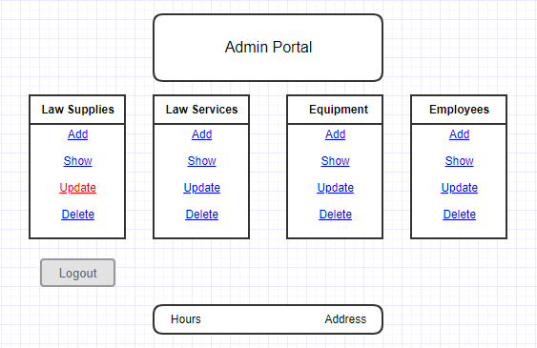

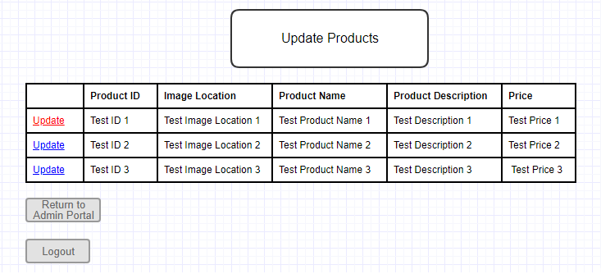

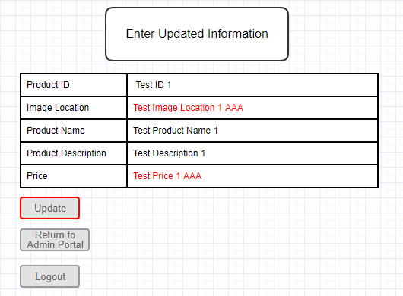

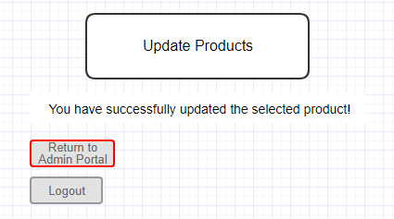

**Deleting Supplies**

When Delete Supplies is selected, the app will allow you to select what product you want to delete. Once you select the product, clicking on the Delete button will finalize the deletion.

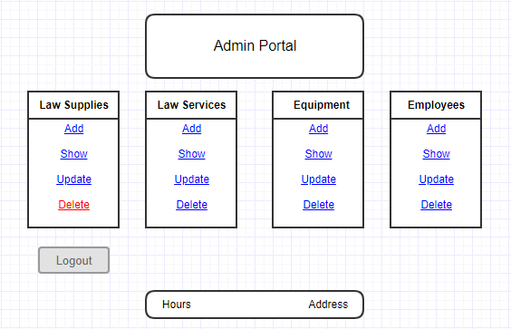

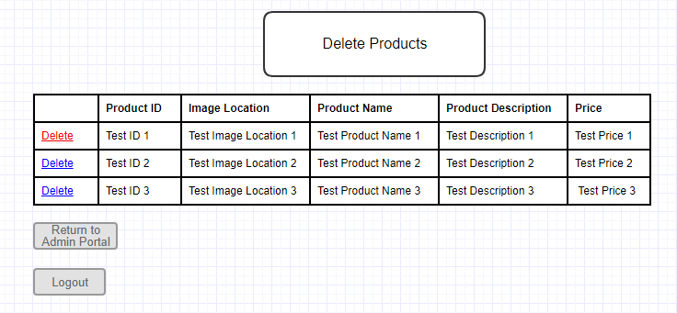

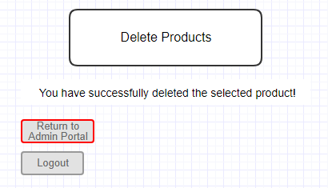

**Admin Logout**

Once you are done using the Admin Portal, you should click on the Logout button, which will securely log you out.

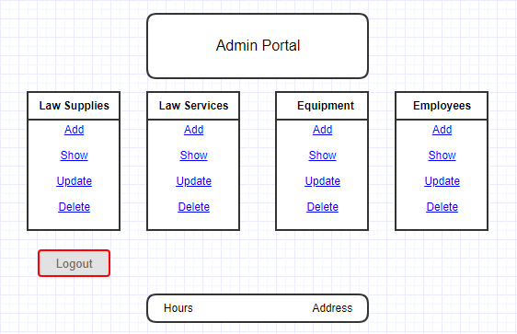

## Customer User

As a Customer User of the E-commerce web application, you will be able to access Services, Landscaping Supplies, Tips, About Us, and Contact Pages. You will be able to browse the website, review landscaping tips, read about GTLSS, and contact GTLSS Customer Service. This website will also allow you to select the desired product/service, schedule service date, checkout your final order, and place an order by making an online payment.

**Tips Page**

On the Home Page, you can click on the "Tips" link, which will redirect you to the Basic Lawn Care Tips page.

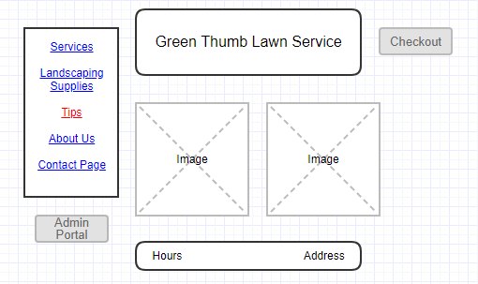

The Landscaping Tips page displays lawn services tips (e.g. proper mowing, proper watering, best times for planting, tips for fertilization, tree trimming, etc.)

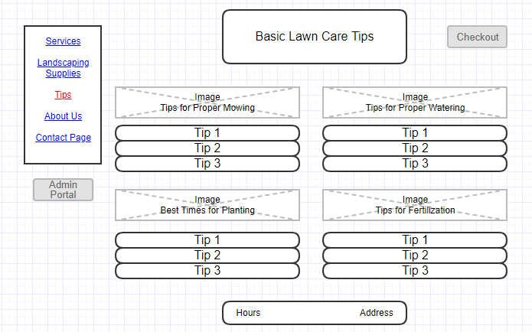

**About Us Page**

On the Home Page, you can click on the "About Us" link, which will redirect you to the About Us page.

The About Us page displays information about the E-commerce lawn services company (GTLSS), including a Company Bio, Honored employees, and Community Service.

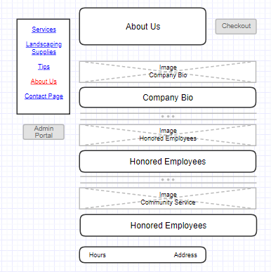

**Contact Us Page**

On the Home Page, you can click on the "Contact" link, which will redirect you to the Contact Us page.

The Contact Us page provides the option to write a comment or question and then email that to the Customer Support team of the E-commerce lawn service company. You will have to provide your name, phone number, and email address into the appropriate fields. Once you finish writing your comment or question, click Send Email button.

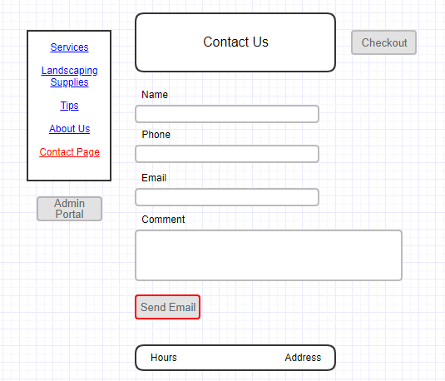

**Landscaping Supplies Page**

On the Home Page, you can click on the "Landscaping Supplies" link, which will redirect you to the Landscaping Supplies page.

The Landscaping Supplies page allows you to select the desired landscaping product and its quantity. Once you done with the selection, you should click the "Add to Cart" button. This will result in placing the selected supply order into the shopping cart.

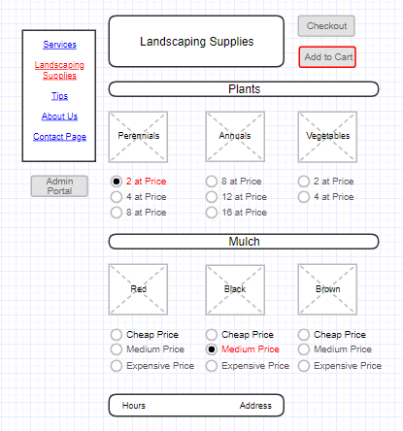

**Services Page**

On the Home Page, you can click on the "Services" link, which will redirect you to the Services page.

The Services page allows you to select the lawn service that fits your needs the best. Once you done with the selection, you should click the "Add to Cart" button. This will result in placing the selected service order into the shopping cart.

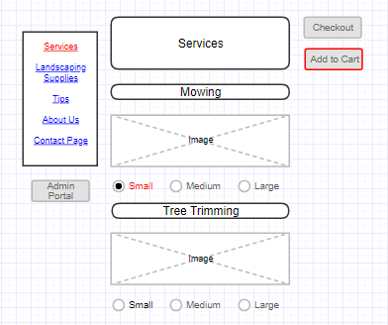

**Checkout**

Once you are done with browsing the website and making your selections, you can click the "Checkout" button available on all pages. This will redirect you to the Checkout page, where you will be presented with an itemized list of Services and Supplies requested.

Check out steps:

* If you did not order any services, you can skip this step and go to the next one.

If you selected any lawn care services, you will be able to schedule the date for the service via this page. Just simply chose one of the available dates on the calendar, which fits your schedule the best.

* After reviewing your order and (if applicable) selecting date of service, fill out the billing form providing information like your name, email, address, credit cart type, number and expiration date.
* When you are done with filling out your billing information, click on the "Submit Order" button.

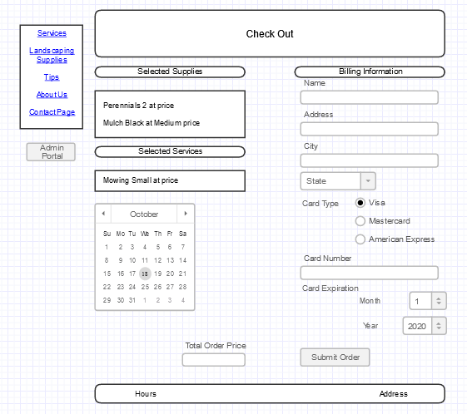

* Once your payment information is verified, you will receive the order confirmation.

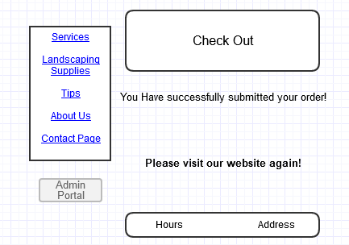

The source code can be found at: https://github.com/green-thumbs.

Thank you for using Green Thumb Lawn Service System!

